AMAZON TOP 50 BOOKS SUMMARY

Introduction
This Excel dataset is a collection of data related to the top 50 best-selling books on Amazon for each year between 2009 and 2019.
The Amazon Top 50 Bestselling Books can be used to explore trends in book sales on Amazon for over a decade. In this dataset we are going to find the average rating of the books, the price range of the books, the author's details, and how much business has been done by price and by region, We find a correlation between price and user rating.

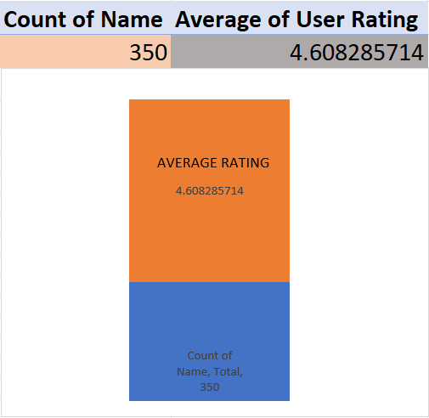
METHODS
For finding the average rating of the books
Insert the data table into power pivot use the average function on the column of ratings and use the count function on the column of books name. visualize the result by using a bar chart

Highest price book:
Find the book that has the highest price
Insert the data table into the pivot table using the sum () function on the column of price and use the count () function on the column of book name. then apply filter by values and select top 1 (book name) by value (sum of price) and in the result I found the book “Diagnostic and Statistical Manual of Mental Disorders, 5th edition” is the highest price ($105) book.

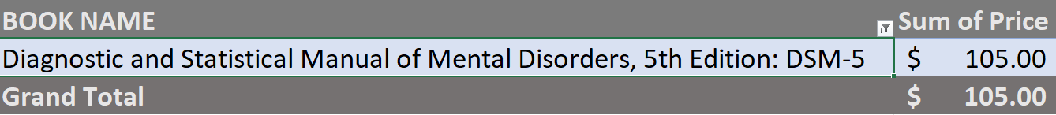

The Author who has the highest average rating:
There is the highest user rating is 4.9 and I found more than one author who has the highest average rating. Such as Emily Winfield Martin, Alice Schertle, Eric Carle, Bill Martin Jr. , and Chip Gaines all five authors have 4.9 average ratings.

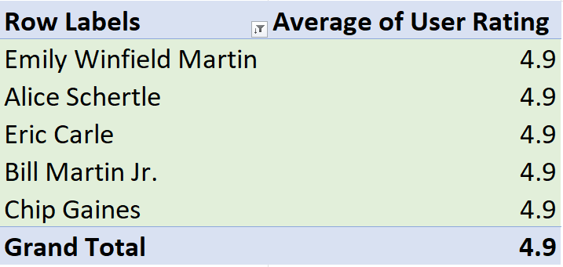

The Author Jeff Kinney, Who has the most number (12) of books in the top 50 best-sellers
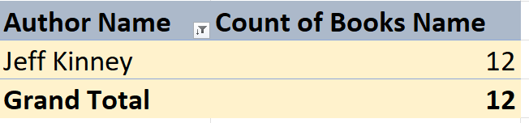

There is the highest user rating in the USA is 4.8 and I found more than one author who has the highest user rating. Such as R.J.Palacio, Laura Hillenbrand, Crispin Boyer, and David Goggins all these 4 authors have a 4.8 user rating.
The authors, who have in the United States the highest average User Ratings are:
Average of User Rating | Column Labels
Row Labels | United States | Grand Total
R. J. Palacio | 4.8 | 4.8
Laura Hillenbrand | 4.8 | 4.8
Crispin Boyer | 4.8 | 4.8
David Goggins | 4.8 | 4.8
Grand Total | 4.8 | 4.8

CORRELATION:
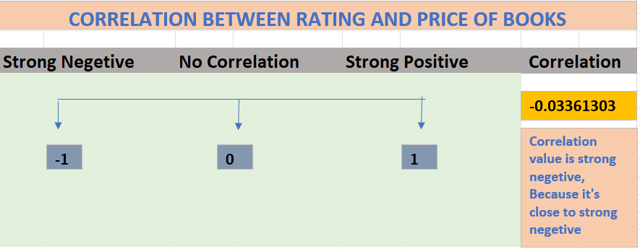
Correlation interpretation, -0.033 is close to 0 therefore there is no correlation.

CORRELATION ON THE SCATTER CHART:

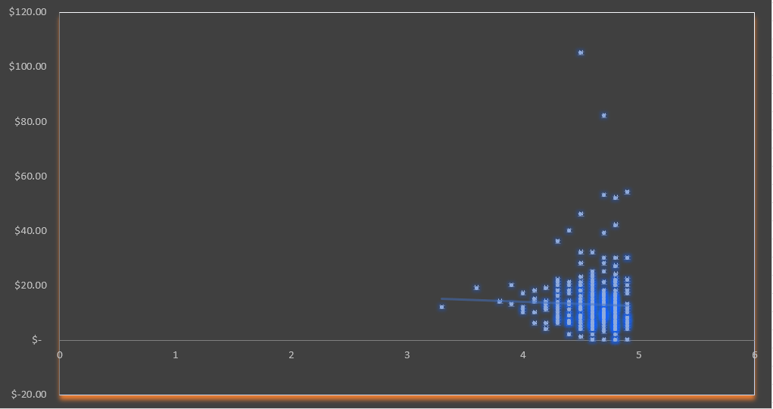
Here display authors’ names who lived in the USA and their ages are under 50 years, by adding the author’s name, and age into the power pivot table and filtering by age less than 50 years old.
There is a total of 6 authors who lived in the United States they all are under 50 years old.

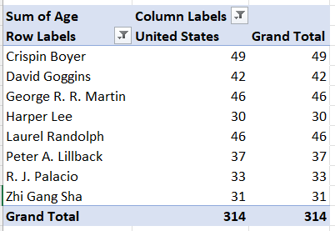

The proportion of the genres of the books are shown below:
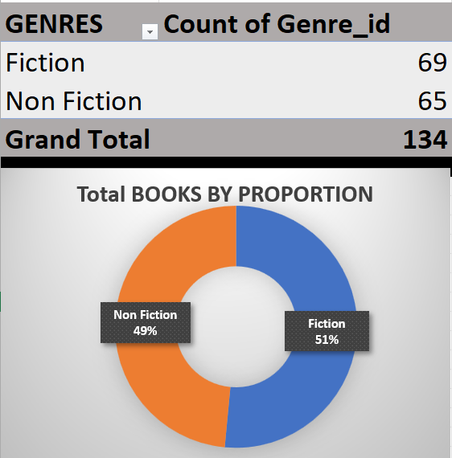

The price range distribution of the books:
- Created a new column titled Price Range and use IF () function with multiple conditions.
- CONDITIONS:
- if the price is greater than or equal 60 - Expensive
- if the price is greater than or equal 30 - Affordable
- if the price is greater than or equal 10 - Cheap
- anything other than these - Low

FORMULA
=IF(E2>=$R$2, $T$4, IF(E2>=$R$3, $T$5, IF(E2>=$R$4, $T$6, $T$7))))

Here displays the price distribution of books by adding the price range column into rows and the price range column into values as well, In the power pivot table and use the count () function in the values bar, for counting price range. Sorting count of price range by descending order.
Price distribution is in table below.
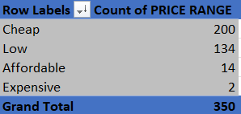

Price distribution is shown by using a bar chart:
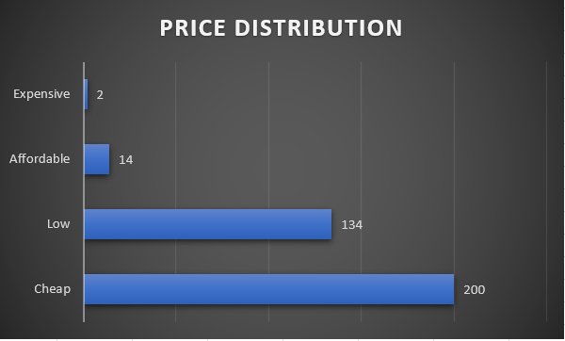

Do we have more Cheap books than Expensive ones?
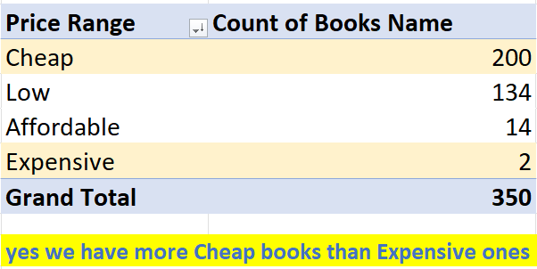

Dashboard
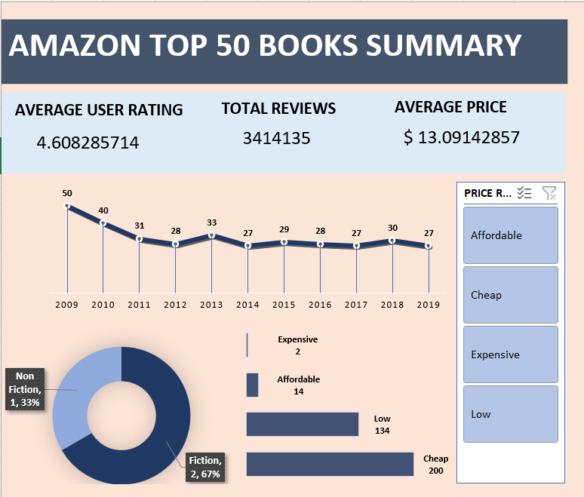

FEEDBACK

I found some outliers in the scatter chart which shows the data is not cleaned.
In the best seller table, I found some book's prices were $0 which indicates that some data entry mistakes are there.
Name | Price
Cabin Fever (Diary of a Wimpy Kid, Book 6) | $ 0
Diary of a Wimpy Kid: Hard Luck, Book 8 | $ 0
Frozen (Little Golden Book) | $ 0
JOURNEY TO THE ICE P | $ 0
Little Blue Truck | $ 0
The Constitution of the United States | $ 0
The Getaway | $ 0
The Short Second Life of Bree Tanner: An Eclipse Novella (The Twilight Saga) | $ 0
To Kill a Mockingbird | $ 0

Two types of books are in these tables one is fiction and the second one is non-fiction. If we look at it, fiction books sold more than non-fiction, people buy 67% fiction books and 33% non-fiction books which is a huge difference between both.
I distribute books priced by 4 groups such as expensive, affordable, cheap, and low When I checked the number of sold books by price range, I got the maximum sold books from the cheap price category, and the least number of sold books were from the expensive price category. Maybe people like to buy cheap price books or maybe the cheap price books have more interesting content that’s why these sold more than other books.
Maximum number of books sold in the year 2009. After 2009 Book sales continually decreased from the year 2010 to 2019. The reason behind this may be its high price or low quality of content.
Jeffy Kinney is the author. His 12 books were included in the list of top 50, most seller books on Amazon and he is the one who has the maximum books in the list.

